**File Maintenance Commands:**

a. **Creating a backup of a directory using the cp command**:

1. Navigate to the parent directory:

* Use the cd command to navigate to the directory that contains the directory you want to back up.

2. Using the cp command with the -r, -rp, and -rv options:

* The -r option recursively copies all files and subdirectories within the specified directory.
* Use the -p option to preserve file attributes like permissions, timestamps, and ownership.
* Use the -v option to display the names of files and directories as they are copied.

3. Specify the source and destination directories:

* Source directory: The directory you want to back up.
* Destination directory: The location where you want to create the backup.

Syntax:

For -r option -> cp -r source_directory destination_directory

For -rp option -> cp -rp source_directory destination_directory

For -rv option -> cp -rv source_directory destination_directory

Example: Here, the source directory is Sample and Backup, Backup1 and Backup2 are created.

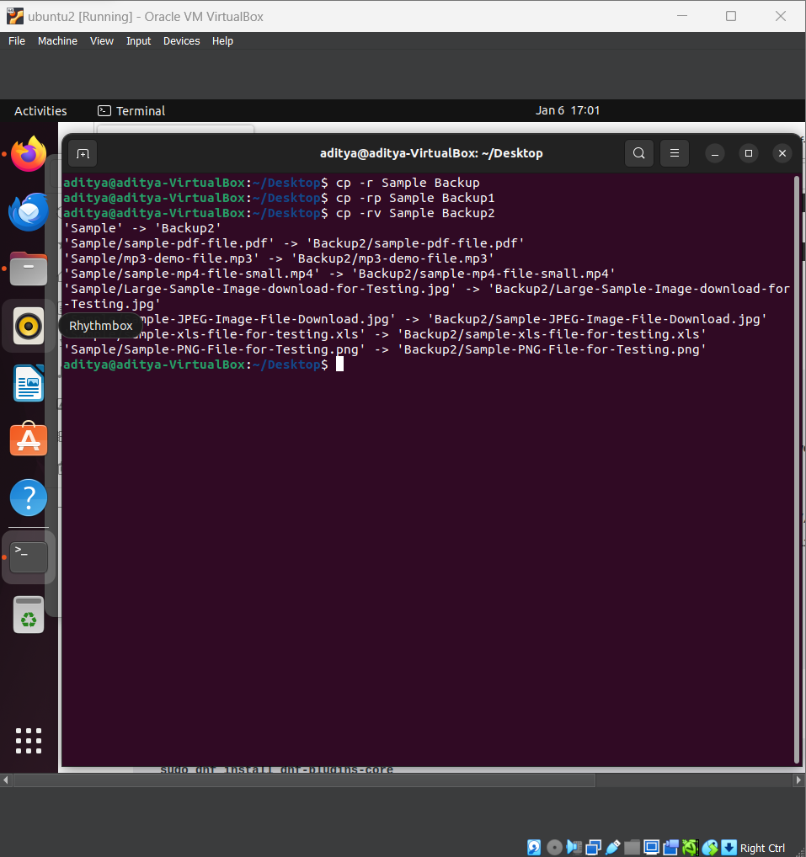

**b.** **Deleting files that match a specific pattern**:

Using the rm command with wildcards to delete files that match a certain pattern.

Here, the .jpg files are deleted from the Sample folder.

The Sample folder screenshot before the deletion:

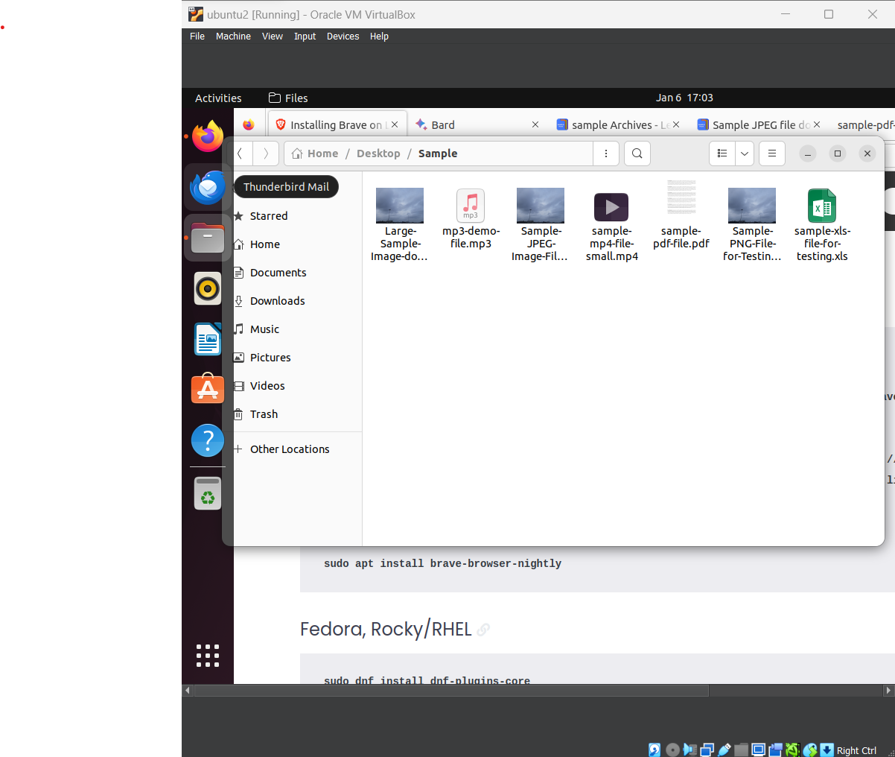

After the deletion using the rm command:

